**KEEP UP TURATI**

Hi Adriano, below I have taken some screenshots of the site and indicated which content must still be filled:

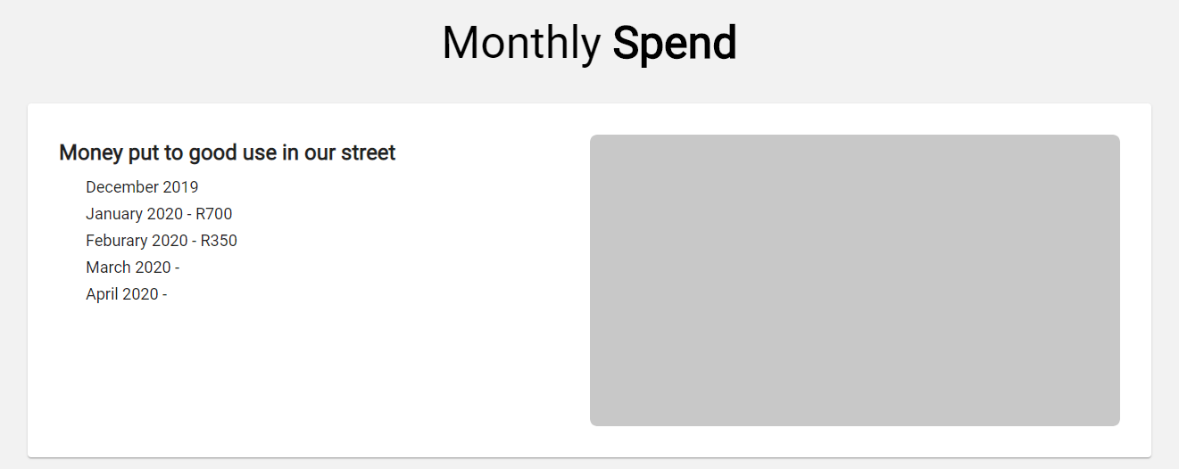

This is on the home page, what graph or image would you like to go here for now?

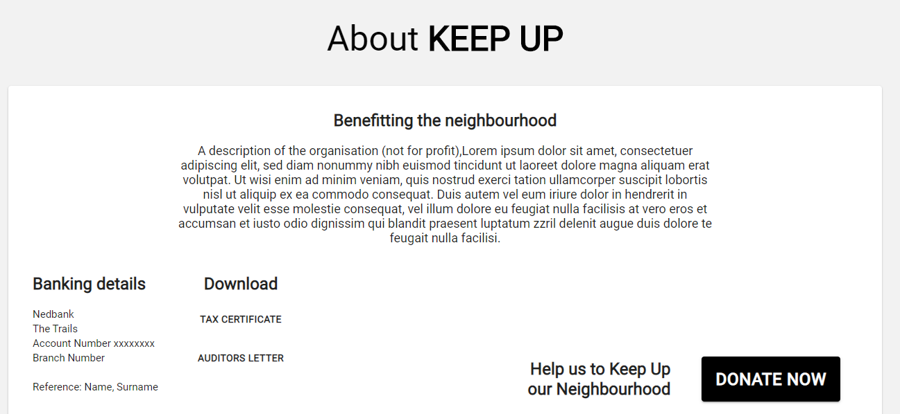

On the about page, I will need the banking details as well as that paragraph on benefitting the neighbourhood. Also the tax certificate and auditors letter.

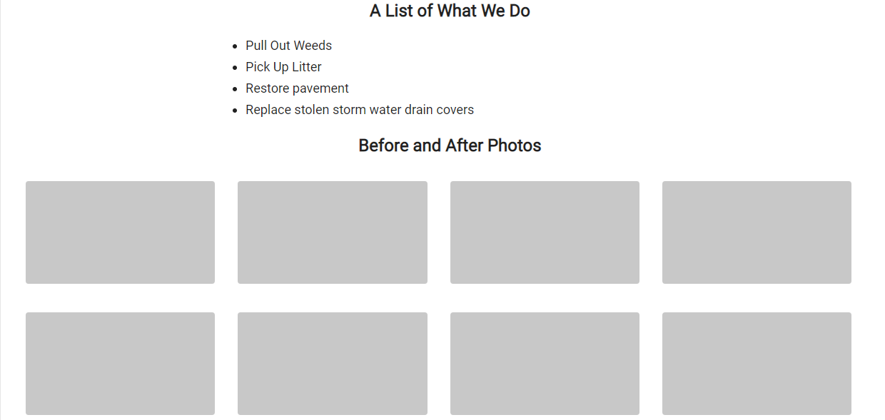

For this section I will need the before and after photos

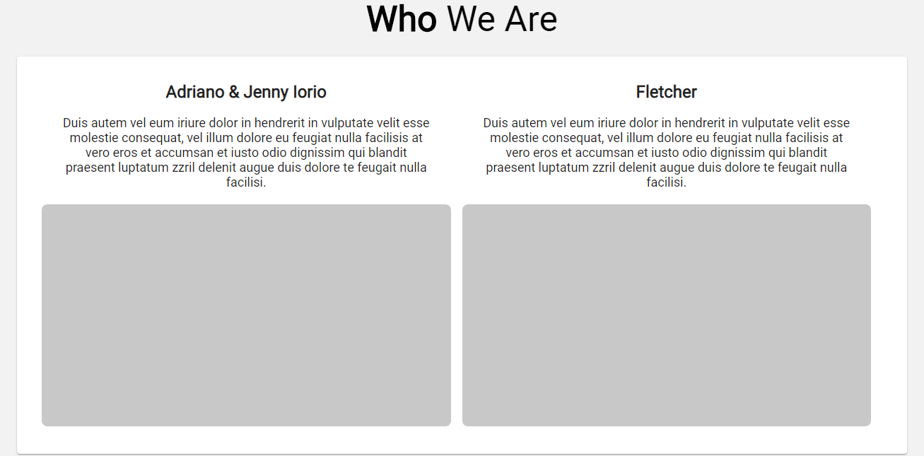

On this page I will need the images of Fletcher and yourself also come content for the short paragraph to preface the image.

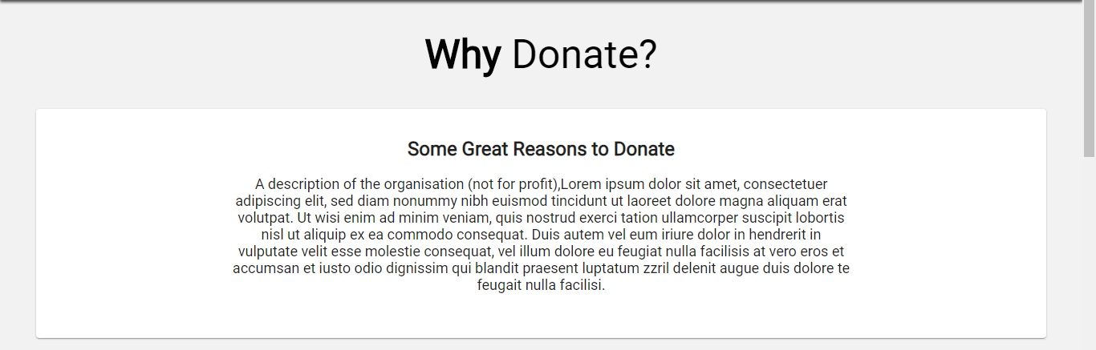

The reasons to donate are needed for a list/short paragraph.

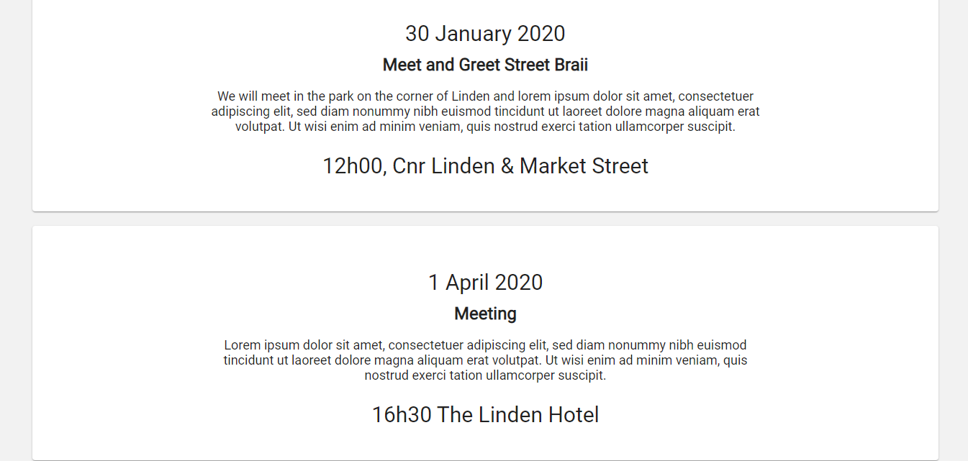

Some information is needed for these events, or perhaps since they are none scheduled I can change the page to indicate “COMING SOON”

I will also require the media pack if available or I can also just change the page to indicate “COMING SOON”.

Thanks Adriano